Customer Shopping Behaviour Analysis

Project Overview
The aim of this project is to analyze customer shopping behaviour using transactional data from 3900 purchases across different product categories. The objective is to understand patterns on how customers shop, how much they spend, what products they prefer, and how subscription status affects purchasing behaviour. By analyzing these factors, useful insights can be generated that may help businesses make better decisions related to marketing, pricing, and customer engagement.

Dataset Summary
The dataset used for this project contains 3900 rows and 18 columns. It includes information about customers, their purchases, and their shopping behaviour.
Some of the important features in the dataset are:
- Customer Information: Age, Gender, Location, and Subscription status.
- Purchase details: Item Purchased, Category, Purchase Amount, Season, Size, and colour.
- Shopping Behaviour: Discount Applied, Promo Code Used, Previous Purchases, Frequency Of Purchases, Review Rating and Shipping Type.
While examining the dataset, it was found that the Review rating column had 37 missing values, which needed to be handled during the data cleaning process.

Exploratory Data Analysis using Python
The first step in the project was to clean and prepare the dataset using Python.

- Data Loading: The dataset was imported into Python using the pandas library, which is commonly used for data analysis.
- Initial Data Exploration: To understand the structure of the dataset, functions such as df.info() were used to check the column types and overall structure, while df.describe() helped generate summary statistics for numerical columns.

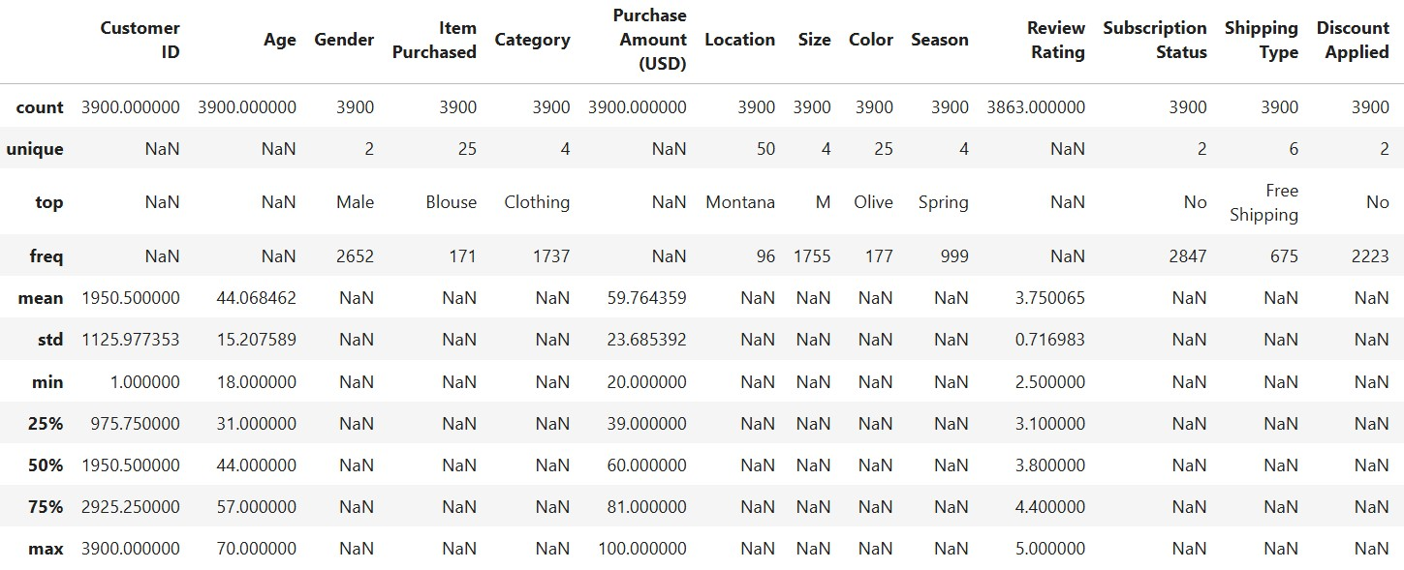

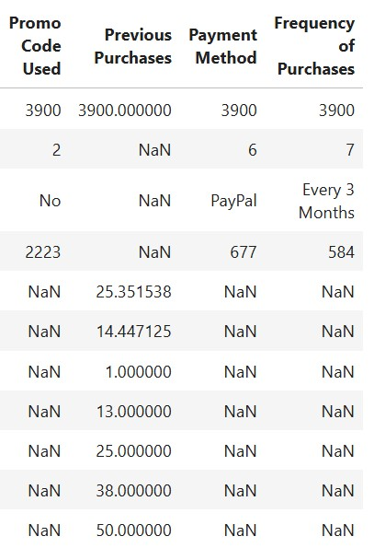

- Handling Missing Values: The missing values in the Review Rating column were handled by replacing them with the median review of each product category. This method helps maintain realistic values in the dataset.
- Column Standardization: For better readability and consistency, the column names were converted into snake case format.
- Feature Engineering: Some new columns were created to improve the analysis:
  - age-group: Customers were grouped into different age ranges based on their age.
  - purchase_frequency_days: This column was created from purchase data to understand how frequently customers make purchases.
- Data Consistency Check: The columns discount_applied and promo_code_used were checked to see if they contained similar information. Since both columns represented almost the same thing, the promo_code_used column were removed to avoid redundancy.
- Database Integration: After cleaning the data in Python, the dataset was connected to PostgreSQL and the cleaned DataFrame was loaded into the database. This allowed further analysis to be performed sing SQL queries.

Data Analysis using SQL(Business Transactions)

Several SQL queries were written in PostgreSQL to answer different business related questions.

- Revenue by Gender - The total revenue generated by male and female customers was calculated to compute spending patterns between the two groups.

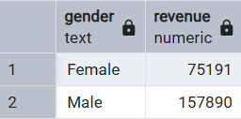
- High-Spending Customer using Discounts – Customers who used discounts but still spent more than average purchase amount were identified. This helps understand whether discounts attract high value customers.

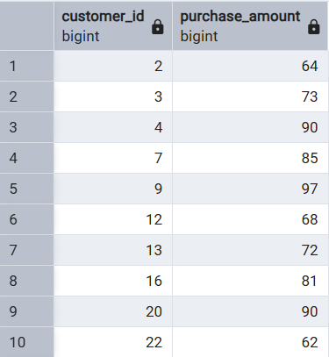

- Top 5 Products by Rating - The analysis identified five products with the highest average review ratings, which indicates the products that customers are most satisfied with.

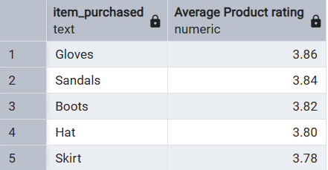

- Shipping Type Comparison – The average purchase amount was compared between Standard Shipping and Express Shipping to see if shipping preferences affects how much customers spend.

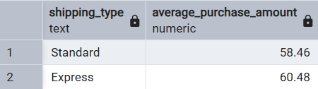

- Subscribers vs Non-Subscribers – The spending behaviour of subscribers vs non-subscribers was compared by analyzing their average purchase amount and total revenue contribution.
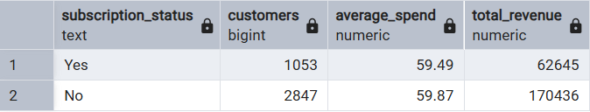

- Discount-Dependent Products – The analysis also found the five products with the highest percentage of purchases made with discounts, which shows which products rely more on promotional offers.

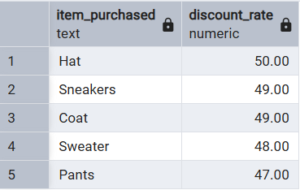

- Customer Segmentation – Customers are divided into three categories based on their purchase history:
- New Customers
- Returning Customers
- Loyal Customers
This helps businesses better understand customer loyalty and engagement.

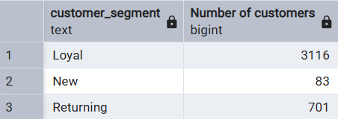

- Top 3 Products per Category – For each category, the top three most purchased products were identified.

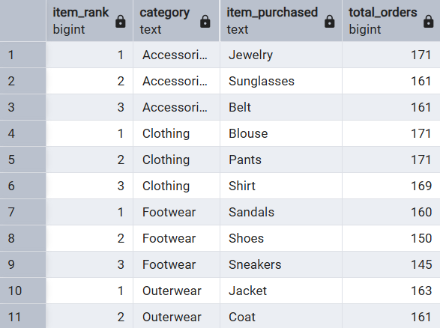

- Repeat Buyers and Subscriptions - The analysis checked whether customers who made more than five purchases were more likely to subscribe.

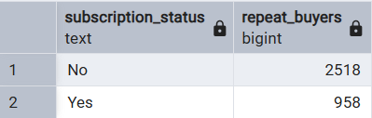

- Revenue by Age Group – The total revenue generated by each age group was also calculated to understand which group contributes the most to sales.

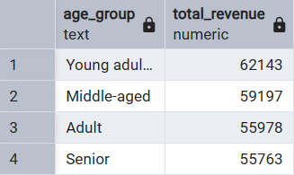

Dashboard in Power BI

After completing the analysis, a Power BI dashboard was created to visually present the insights.

The Dashboard helps in understanding patterns related to:
- Customer demographics
- Product performance
- Revenue trends
- Shopping behaviour
Using visualisations makes it easier to interpret the results and share insights with others.

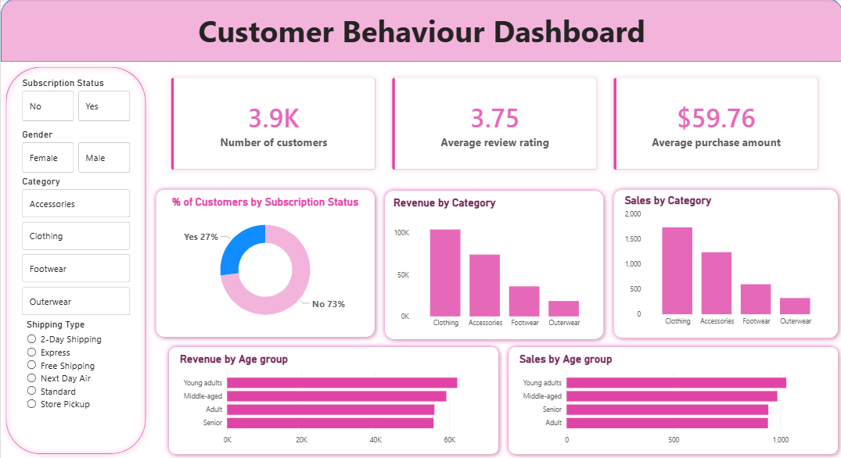

Business Recommendations

Based on the analysis, the following recommendations can be made:
- Encourage Subscriptions- Businesses can offer special benefits or discounts to encourage more customers to subscribe.
- Create Loyalty Programs- Rewarding repeat customers may help move them into the loyal customer segment, which can increase long-term sales.
- Review Discount Strategy- Discounts should be used carefully so that they increase sales without reducing profit margins too much.
- Promote Popular Products- Highly rated and frequently purchased products should be highlighted in marketing campaigns.
- Use Targeted Marketing- Marketing strategies can focus more on age group that generate higher revenue and customers who prefer express shipping.

